Student ID:18009525
Predicting National Life Evaluation: Extending World Happiness Report Factors with Safety, Environment and Work-Life Indicators
Abstract
This project investigates whether selected non-financial country-level variables improve prediction of national life evaluation when introduced to a predictive model in addition to the standard World Happiness Report explanatory factors. The study uses the WHR country-year data from 2019 onwards and adds in homicide rate, sunshine hours, paid leave, and average retirement age. These were chosen as representatives of civil safety, environment, and work-life balance.
K-means clustering was used descriptively to identify similar groups of countries.
Random Forest regression models were used to compare prediction using the original WHR factors with prediction using the expanded factor set. Both models were evaluated using the same complete observations and training/test split.
The expanded model achieved lower prediction error and stronger fit than the baseline model. RMSE reduced from approximately 0.462 to 0.337, while R-squared increased from 0.811 to 0.899. This suggests the introduced variables provide additional predictive power. Sunshine hours and retirement age showed particularly high permutation importance.
The findings are predictive rather than causal. Uneven data coverage limits the conclusions.
The project delivers R-analysis and visual outputs including Tableau boards.
Contents:
- Intro
  - Context
  - Rationale
  - Problem and Scope
  - Aims and Objectives
2. Research
2.1 Literature
2.2 Replication Study
3. Artifact
3.1 Proposed Artifact
3.2 User Needs and Relation to Objectives
3.3 Data Sources
4. Methodology
4.1 Data Preparation
4.2 Clustering
4.3 Predictive Modelling
5. Results
5.1 Model Comparison
5.2 Cluster Results
5.3 Tableau Maps
6. Conclusion
6.1 Evaluation of Artefact
6.2 Limitations of approach
6.3 Extent to which Aims have been met and Next Steps
6.4 Extent to which the problem is solved
6.5 Supervision Evidence
7. References

1. Intro
1.1 Context
The World Happiness Report, published by the University of Oxford, uses responses from the Gallup World Poll combining data from over 140 countries. Respondents are asked to assess their current life on a scale of 0 to 10 where 10 is the best possible life and 0 is the worst. This question is derived from the Cantril Self-Anchoring Striving Scale. Each country is assigned a yearly countrywide life-evaluation score based on the aggregate results. In 2019 it began to include explanatory factors, which in addition to GDP per capita (the financial factor), includes social support, healthy life expectancy, freedom to make life choices, generosity and perceptions of corruption. (World Happiness Report, 2025). The definitions of these factors according to the WHR are as follows:
- GDP per Capita: “In terms of Purchasing Power Parity adjusted to constant 2017 international dollars, taken from the World Development Indicators by the World Bank.”
- Social Support: “If you were in trouble, do you have relatives or friends you can count on to help you whenever you need them, or not?”
- Healthy Life Expectancy: “Based on data from the World Health Organization Global Health Observatory. The most recent data is from 2021.”
- Freedom: “Are you satisfied or dissatisfied with your freedom to choose what you do with your life?”
- Generosity: “Have you donated money to a charity in the past month?”
- Perceptions of Corruption: “The average of two questions: “Is corruption widespread throughout the government or not?” and “Is corruption widespread within businesses or not?” Where data for government corruption are missing, the perception of business corruption is used as the overall corruption-perception measure.”
However, there numerous other factors that could be considered as further potential predictors of happiness, such as environmental conditions, civil safety, work-life balance and retirement-policy.

1.2 Rationale
The objective of this study is to consider other potential factors beyond those already covered in the World Happiness Index. Countries with similar levels of income and social support may differ greatly in these other areas. This study aims to test the predictive power of these additional factors. This is to be treated as an extension of the existing WHR framework rather than a claim that it is inadequate.
This project does not aim to estimate the effect of changing these variables as the associations may be driven by measures not included in the data.

1.3 Problem and scope
The project does not determine causes of happiness, rather, it measures a variety of factors that are correlated, to some degree, which may or may not be causes. It tests whether selected additional, non-financial, country-level variables improve prediction of happiness.
1.4 Aim and Objectives
“How are non-financial factors correlated with a population’s perception of happiness, and do these factors improve the predictive performance of a machine-learning model beyond the original factors used in the World Happiness Report?”
The aim is to determine if different types of indicators should be considered as explanatory or correlating factors for happiness evaluation.
Approach:
- Prepare a country-year level dataset merging the existing WHR data and the supplementary datasets that incorporate the additional factors.
- Using a Random Forest model, compare the predictive performance of the model on both the base WHR explanatory factors and upon the extended set of candidate predictors. These include: homicide rate, sunshine hours, paid leave and retirement age. Evaluate models on the same set of observations using the RMSE, correlation coefficient and R-squared measures.
- To perform country-level cluster analysis using both WHR variables and the additional candidate variables using K-Means.
- Produce charts, tables and a dashboard to inspect the results and better understand the dynamics of the dataset, along with correlations.

2. Research
2.1 Literature
The World Happiness Report has been widely studied. Some significant relevant contributions follow:
Helliwell et al identify social support as one of the most important factors associated with national life evaluation (World Happiness Report, 2025). Social support refers to how much someone feels they can rely on others. This suggests that relationships, community connections and social safety nets matter alongside material living standards.
Deaton identified that National wealth and income are strongly associated with life evaluation. Higher per capita national income is strongly associated with life satisfaction. A doubling in income corresponds to a 1-point increase on the happiness scale (Deaton, 2008). He found that the effect holds true across the whole range of national incomes, and that health and life expectancy played only a small part. As it is known that wealth relates to happiness, this project focuses on introducing non-financial factors solely. Clearly wealth is significantly correlated to health – money buys better healthcare, treatments, etc.
A 2018 study by Alfaro-Beracoechea combined 12 studies across 39 countries and found a greater fear of crime is linked to lower subjective wellbeing (Alfaro-Beracoechea et al., 2018). While the strength of the relationship was relatively small, the effect was most pronounced in Latin American countries. This supports the argument that fears of crime in places where crime is frequent and severe does have a greater impact on wellbeing, and that public safety is undoubtedly a factor in a country’s overall happiness.
Node found that Work-life balance was also a significant contributor to the National Life-Evaluation (Noda, 2020). This study analysed studied work-life balance across men and women in OECD countries and found that stronger work-life balance was positively associated with higher life satisfaction scores across both groups. This is also supported by Haar et al. (2014) who found a link between work-life balance and satisfaction as well, although with varying strength depending on cultural context. OECD evidence argues that hours, scheduling and workers' control over their time can affect health, work-life balance and job satisfaction (OECD, 2022). Closely related, retirement age may also be considered as predictors for country-wide life evaluation.
Buscha evaluated the impact of sunshine on happiness (Buscha 2016). A study of UK panel data found negligible effect on subjective wellbeing. This suggests that any correlation drawn with sunlight and happiness is likely not causal. Liu, S., Zhang, X. and Zhao, C. (2025) found a small positive impact of sunshine on the day of interview and life satisfaction, but the effect was not strong enough to conclusively point to a relationship. Wider cross-national research suggests that environmental conditions may matter through their interaction with national resources and capacity to adapt (Fischer and Van de Vliert, 2011) The sunshine hours in the new data is likely to correlate with other factors such as tourism, latitude, income, etc.
Taken together, the literature supports inclusion of the new variables as plausible predictors, but it does not necessarily justify treating them as direct causes of happiness.
Nilsson questioned how fully the Cantril Ladder captures wellbeing (Nilsson et al. 2024). Using responses from 1,581 adults, it was found that the ladder framing encouraged people to think more about power and wealth over relationships and wider wellbeing. As the WHR is built using the Cantril Ladder poll, the strong relationship with GDP may be partially influenced by the framing of the poll question. This is a potential limitation, although this study was conducted on a solely UK based population so it may not be representative of other cultures.

2.2 Replication Study
This project is informed by Yang and Xie (2025). Their paper ‘Analysing and predicting global happiness index via integrated multilayer clustering and machine learning models’ attempted to predict global happiness by identifying its drivers using K-means clustering and predictive modelling. They first clustered the countries of the WHR data into ‘high’, ‘medium’ and ‘low’ happiness profiles, and then incorporated the clusters into random forest and XGboost models. They found a 12% increase in R-squared compared to without cluster analysis. Their findings were that the strongest predictors of happiness were GDP and Social Support. This supports using machine learning methods to model non-linear relationships in wellbeing. However, this study acknowledges that some data is missing from lower-income countries. The fact that the clusters are derived from the same factors as the rest of the predictive model makes the added predictive value from them hard to evaluate. It also uses only data from the WHR dataset and not any from the new data elements that this project is considering.
3. Artefact
3.1 Proposed Artifact
This project runs a similar process to Yang and Xie’s study. The artifact is a reproducible R analysis pipeline that produces clustering diagnostics, random forest evaluation tables and plots, and an interactive dashboard. It uses clustering to describe country profiles and a random forest to estimate predictive relationships. However, it will introduce new non-financial factors which are not included in the original WHR explanatory factors feature set. The newly introduced factors are:
- Homicide rate,
- Sunshine hours,
- Paid leave
- Retirement age.
These were chosen as they can be viewed as proxies to represent safety, environment, work-life balance, areas not covered in the original dataset but found in the literature review to be correlated with happiness.
They are to be treated as potential predictive correlates, not direct causes of happiness. They are to be tested for an improvement in prediction beyond that of using just the WHR factors. Unlike Yang and Xie’s study, the clusters will not be integrated into the predictive model but instead be used purely for exploratory purposes. This is because the clusters are derived from the explanatory factors and may display unnaturally high correlation.
Other factors considered but not taken forward due to insufficient data coverage were:
- Attendance at Religious Services
- Hours worked
- Safety after dark
3.2 User Needs and relation to objectives
The primary users of the artefact are people who need to explore and communicate patterns in country-level life evaluation. The artifact needs to be understandable with visual outputs, and reproduceable
3.3 Data Sources
The core life evaluation score and variables come from the World Happiness Report country-year dataset.
Homicide rate was obtained from the United Nations Office on Drugs and Crime (UNODC) dataset.
Safety after Dark was obtained from the United Nations Office on Drugs and Crime (UNODC) dataset.
Sunshine hours came from a city-level Kaggle dataset.
Hours worked data were obtained from ILOSTAT (International Labour Organization (ILO), 2026).
Average vacation days per country was obtained from the World Population Review (World Population Review, 2026).
Retirement Age by country was obtained from the World Population Review (World Population Review, 2026).
The Religious attendance data was sourced from Our World in Data, specifically Ritchie et al., (2026).
All the data is aggregated and anonymous. There is no presence of individuals names or personal identifiers. The only ethical risks concern data quality rather than personal data disclosure.

- Methodology

  - Preparation
The core dataset is the World Happiness Report country-year dataset. It is restricted to observations from 2019 and onwards only. This is because before 2019, the report did not include the explanatory factors (GDP per capita, social support, healthy life expectancy, freedom to make life choices, generosity, perceptions of corruption and the residual fluctuation). Missing values in the core data was handled with multiple imputation using predictive mean matching, with a seed to make it reproducible. This is the method Yang and Xie used for the same problem. Due to the small amount of missing data, the risk of non-representative data being introduced is small enough to justify this approach. However, the majority of the missing data relates to only 2 countries so a case could be made for dropping them instead. For consistent joining with other datasets later, each country was assigned its ISO3 code. Kosovo required a manual match.
  - Joining
External datasets were joined by country and year where annual data existed. For measures with limited or single year coverage, they were treated as time-invariant characteristics and joined across the whole WHR period. The homicide dataset was filtered to total victims of intentional homicide per 100,000. This created one observation per country year. The city-level sunshine hours data were averaged to produce one value per country.
After joining external data, variables with less than 50% coverage against the WHR base were dropped. The removed variables were Religious Service Attendance, Hours Worked and Safety After Dark. Initially I had hoped to include them in the model but by removing them I avoid having to use imputation for variables with very limited coverage and potentially introducing false information to the model. The version of the dataset with the new factors had around 300 observations as opposed to the original of approximately 1000.
Factor | Coverage (%) | Primary-model decision
Religious-service attendance | 8.2 | Excluded
Hours worked | 11.2 | Excluded
Safety after dark | 20.7 | Excluded
Average retirement age | 52.9 | Retained
Homicide rate | 55.1 | Retained
Sunshine hours | 81.8 | Retained
Paid-leave measures | 82.0-96.4 | Retained

  - Clusters
K-Means clustering is a method of analysis which involves partitioning observations into a predefined number of k clusters, with observations assigned according to their proximity to cluster means (MacQueen, 1967) The optimal number of clusters can be determined using various methods. Increasing the number of clusters gives diminishing returns.
Before any clustering, all the explanatory variables were standardised so that their differing measurement scales would not affect the distance calculation.
The Elbow, Silhouette and Gap Statistic method for determining the optimal number of clusters to use were used. The Elbow and Silhouette methods suggested a lower number while Gap statistic suggested a higher one. A three-cluster solution was implemented to retain a meaningful middle profile while remaining close to the three-cluster design used by Yang and Xie (2025). This was run on the expanded dataset
While Yang and Xie incorporated the clusters into the machine learning model, here the clusters are reported descriptively rather than used as Random Forest predictors, because they are derived from the same data already supplied to the expanded model. This is an area where this study differs from theirs.

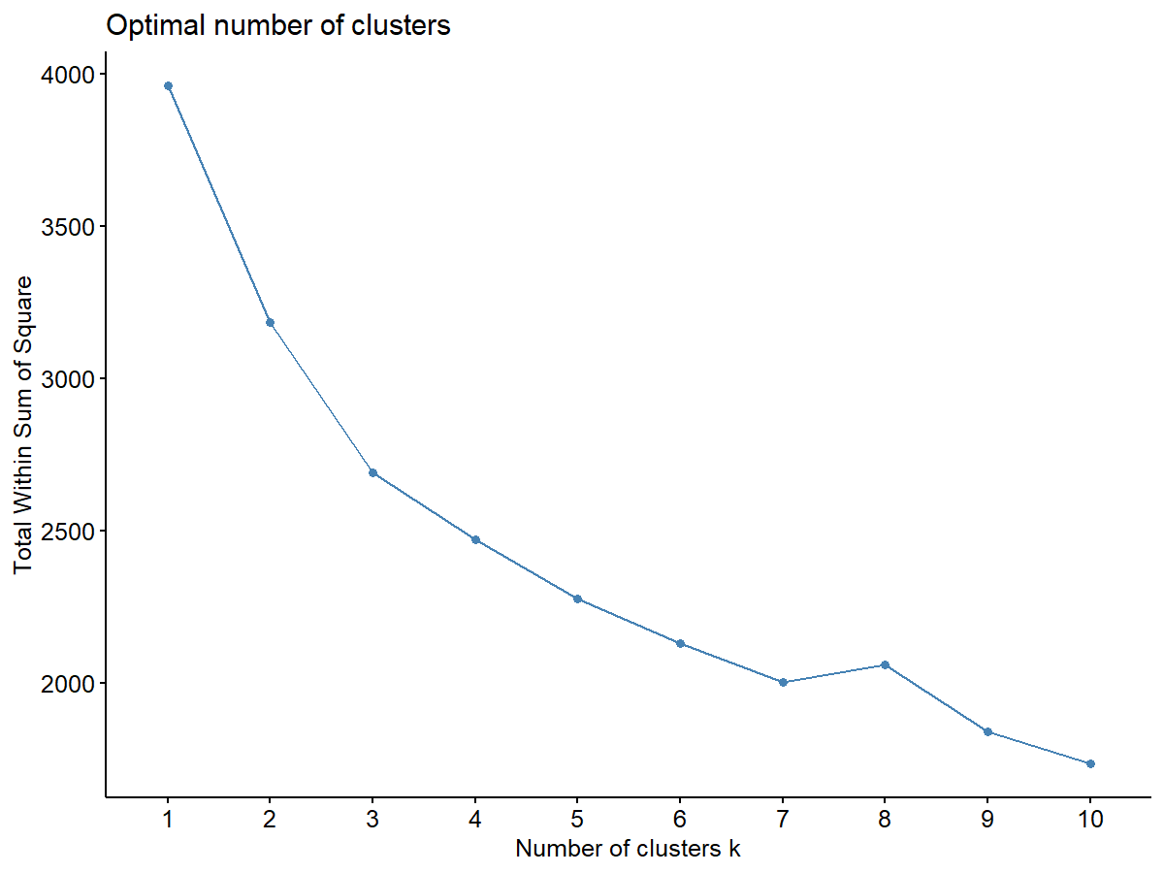
Figure 1 Elbow Method
The elbow method determines variation within each cluster and the point at which adding more clusters provides only a small improvement is called the elbow. (Thorndike, R.L. (1953)
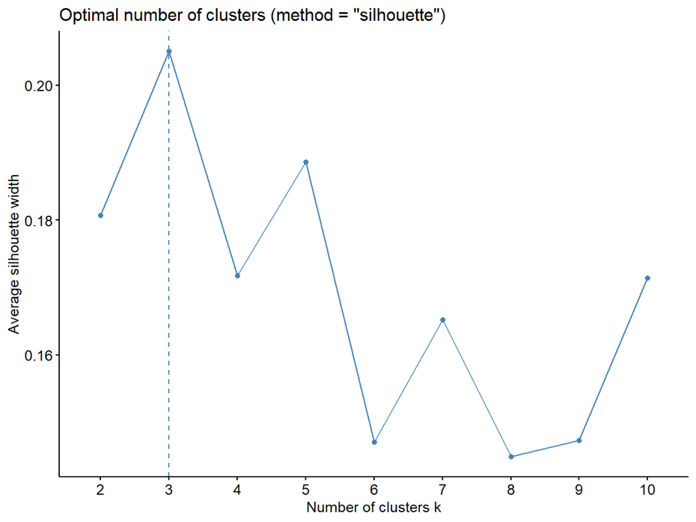
Figure 2 Silhouette Method
The silhouette method was introduced by Rousseeuw (1987) and it determines how similar data points are to its own and other clusters, with scores ranging from -1 to 1, greater scores indicating better separation of clusters.

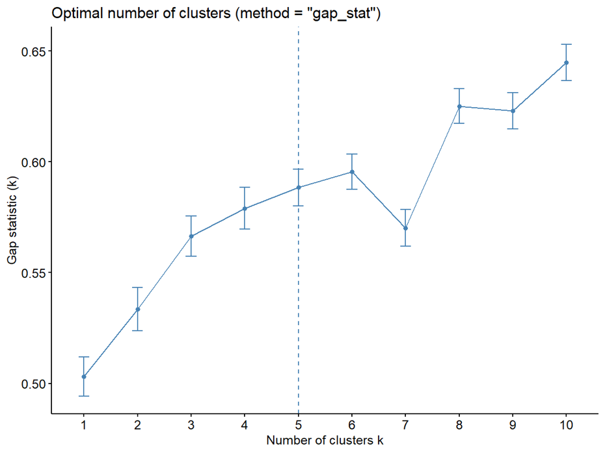
Figure 3 Gap Statistic Method

4.4 Predictive Modelling
Random Forest regression was used as a simple and effective way of handling non-linear relationships.
The data was partitioned into 80% training and 20% test data using a fixed seed. The original and expanded models were evaluated on the same complete rows. RMSE measures prediction error where a smaller value is better. R is the correlation between predictions and observed test values. R-squared is the squared correlation.
AI assistance using ChatGPT was used alongside R for compensating for lack of syntax knowledge and for troubleshooting.
- Results

  - Model Comparison
Model | RMSE | R | R-squared
Original WHR factors | 0.462 | 0.901 | 0.811
Original + New factors | 0.337 | 0.948 | 0.899
The expanded model reduced RMSE by 0.125. The R-Squared increased from 0.811 to 0.899. This indicates that the introduced factors add predictive information beyond the original WHR base set on the same observations.
R-squared shows how much of the variation in the actual life-evaluation scores is explained by the model’s predictions on a scale of 0-1. The expanded model explains a roughly 8.8 percent more variation than the base model.
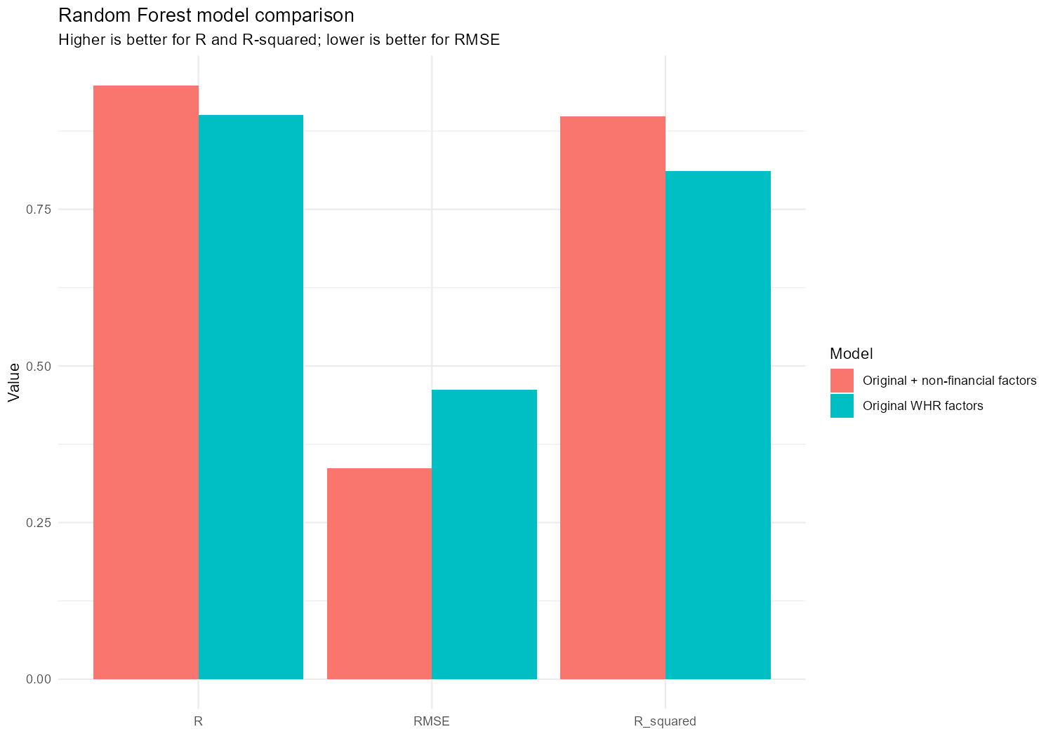
Figure 4: Random Forest Model Comparison
Below is the importance of each factor when the expansion factors are added. Of the new variables, sunshine hours is the greatest contributor followed by average retirement age.
Permutation importance (%IncMSE) measures the increase in prediction error when one predictor is randomly shuffled while the remaining inputs are kept unchanged. A larger value means that the trained model depended more on that variable for prediction.
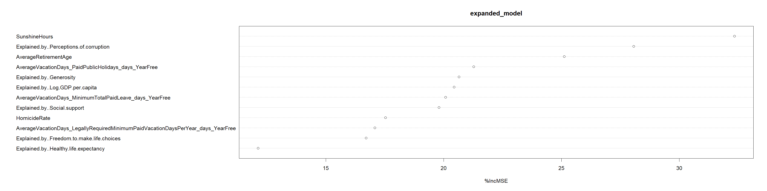
Figure 5: Importance of Factors in Expanded Model

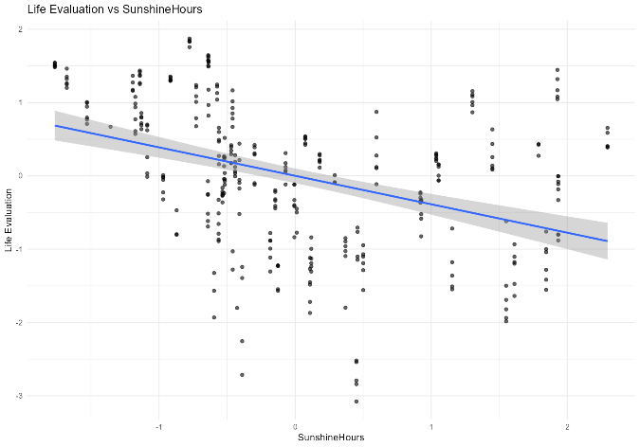
Figure 6: Sunshine Hours to Life Evaluation Scatter

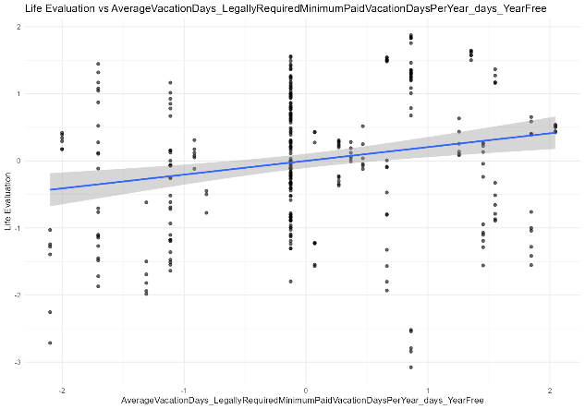
Figure 7: Minimum Vacation to Life Evaluation
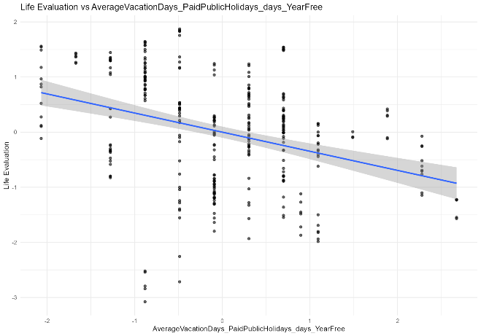
Figure 8: Average Paid Public Holidays to Life Evaluation

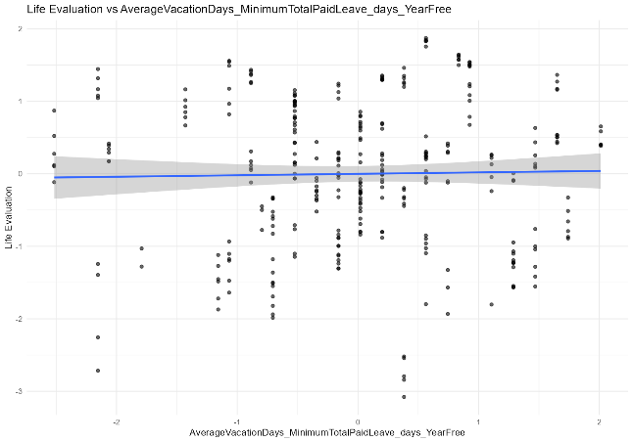
Figure 9: Average Vacation days to Life Evaluation
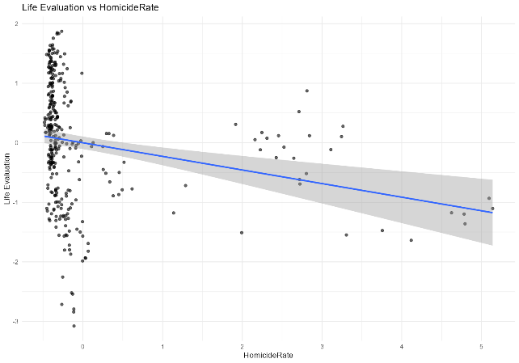
Figure 10: Homicide Rate to Life Evaluation
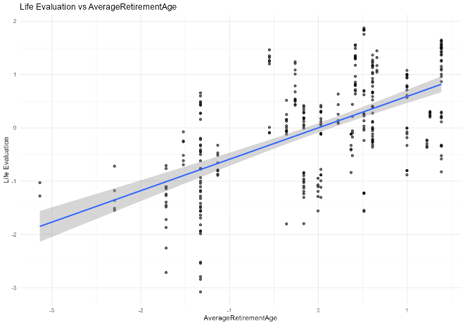
Figure 11: Average Retirement Age to Life Evaluation

As expected, life evaluation lowers with greater homicide rate, although the vast majority of countries have very few homicides. Similarly, there is a positive correlation with minimum paid vacation days. There is little relationship with average paid vacation days.
Interestingly, sunshine hours shows an inverse relationship with life evaluation. It is likely there are other factors which are responsible for this.

  - Cluster Results
Table 1: Average WHR Scores by cluster
Cluster | Life evaluation | GDP | Social support | Health | Freedom | Corruption
1 | -0.314 | -0.044 | -0.066 | -0.038 | -0.283 | -0.492
2 | 1.099 | 0.705 | 0.558 | 0.550 | 0.812 | 1.346
3 | -0.734 | -0.920 | -0.638 | -0.706 | -0.397 | -0.592
Cluster | Retirement age | Homicide rate | Sunshine | Public holidays | Paid leave | Vacation
1 | 0.049 | -0.283 | 0.208 | 0.236 | 0.453 | 0.372
2 | 0.630 | -0.366 | -0.785 | -0.702 | -0.134 | 0.196
3 | -1.076 | 1.349 | 0.571 | 0.367 | -1.095 | -1.353

The clusters are built using the expanded dataset. The upper part of the Table 1 shows the standard WHR part of each cluster profile. The lower part of Table 1 shows the new factors that were also used to construct the clusters.
Cluster 3 has the lowest life evaluation, and least favourable explanatory factors.
Cluster 2 has the highest average life evaluation score and the most favourable scores for the explanatory factors.
Overall, the clusters suggest that the highest life evaluation is associated stronger economic, social, health and institutional conditions.
As a large number of observations were removed from the expanded dataset, this clustering does not incorporate all the data in the original WHR report as it was made with the expanded dataset. Certain countries as a result are not assigned a cluster.
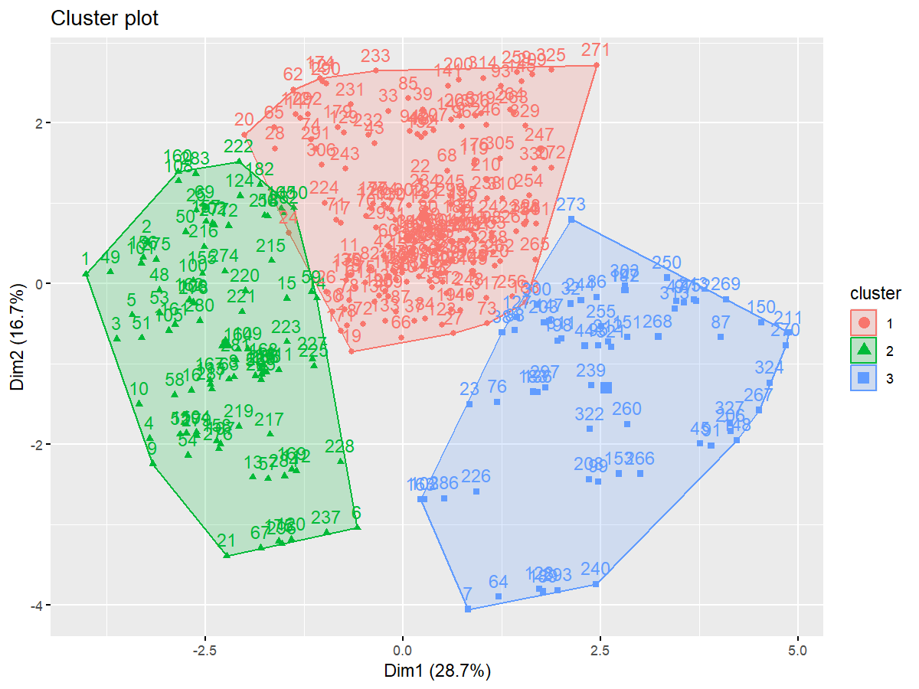
Figure 12: Clusters Plot
  - Tableau Maps
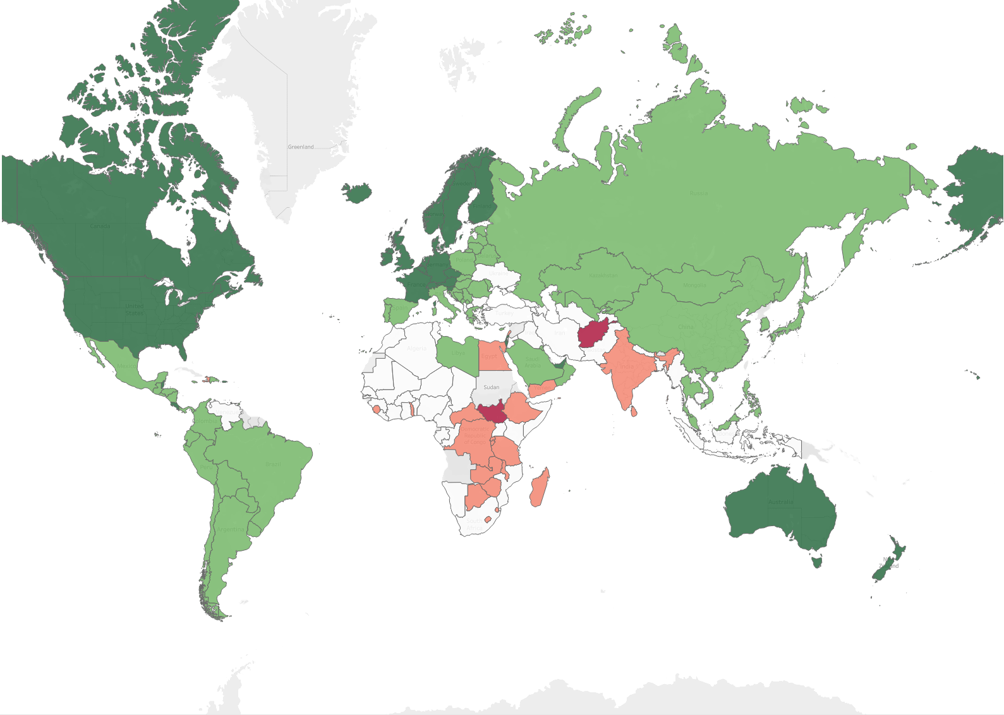
Figure 13: Happiness Score Map (Red-Less, Green-More)
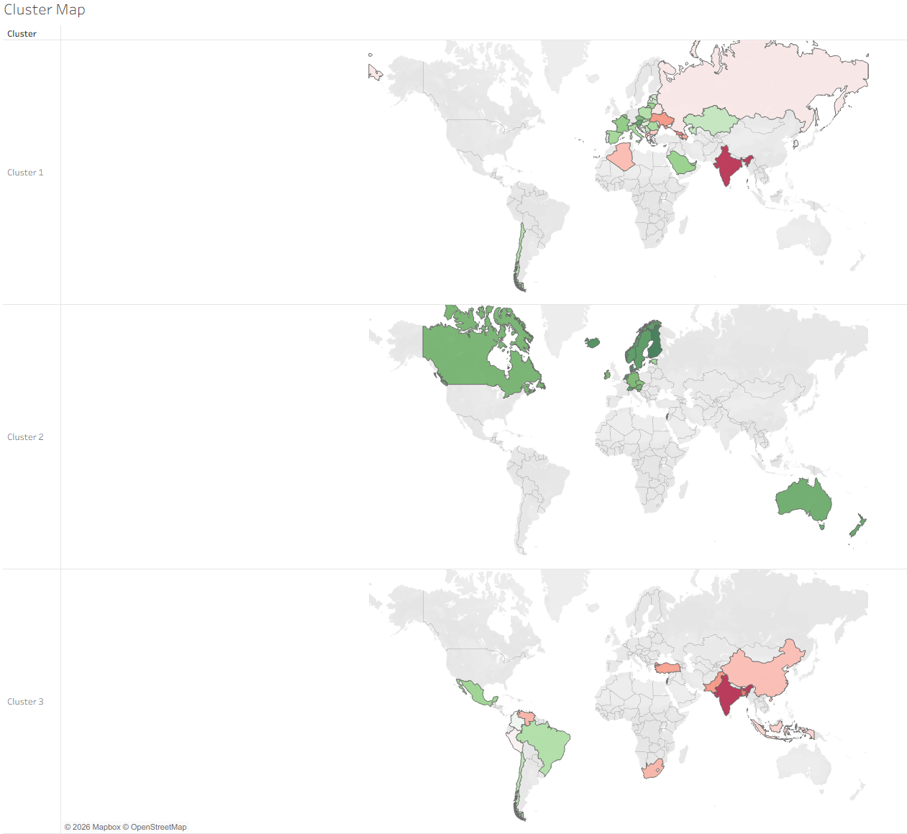
Figure 14: Clusters Geographical Location
This visualisation shows that that many clustered countries are geographically in close proximity to each other, likely due to similar economic and social situations, and have similar happiness scores.
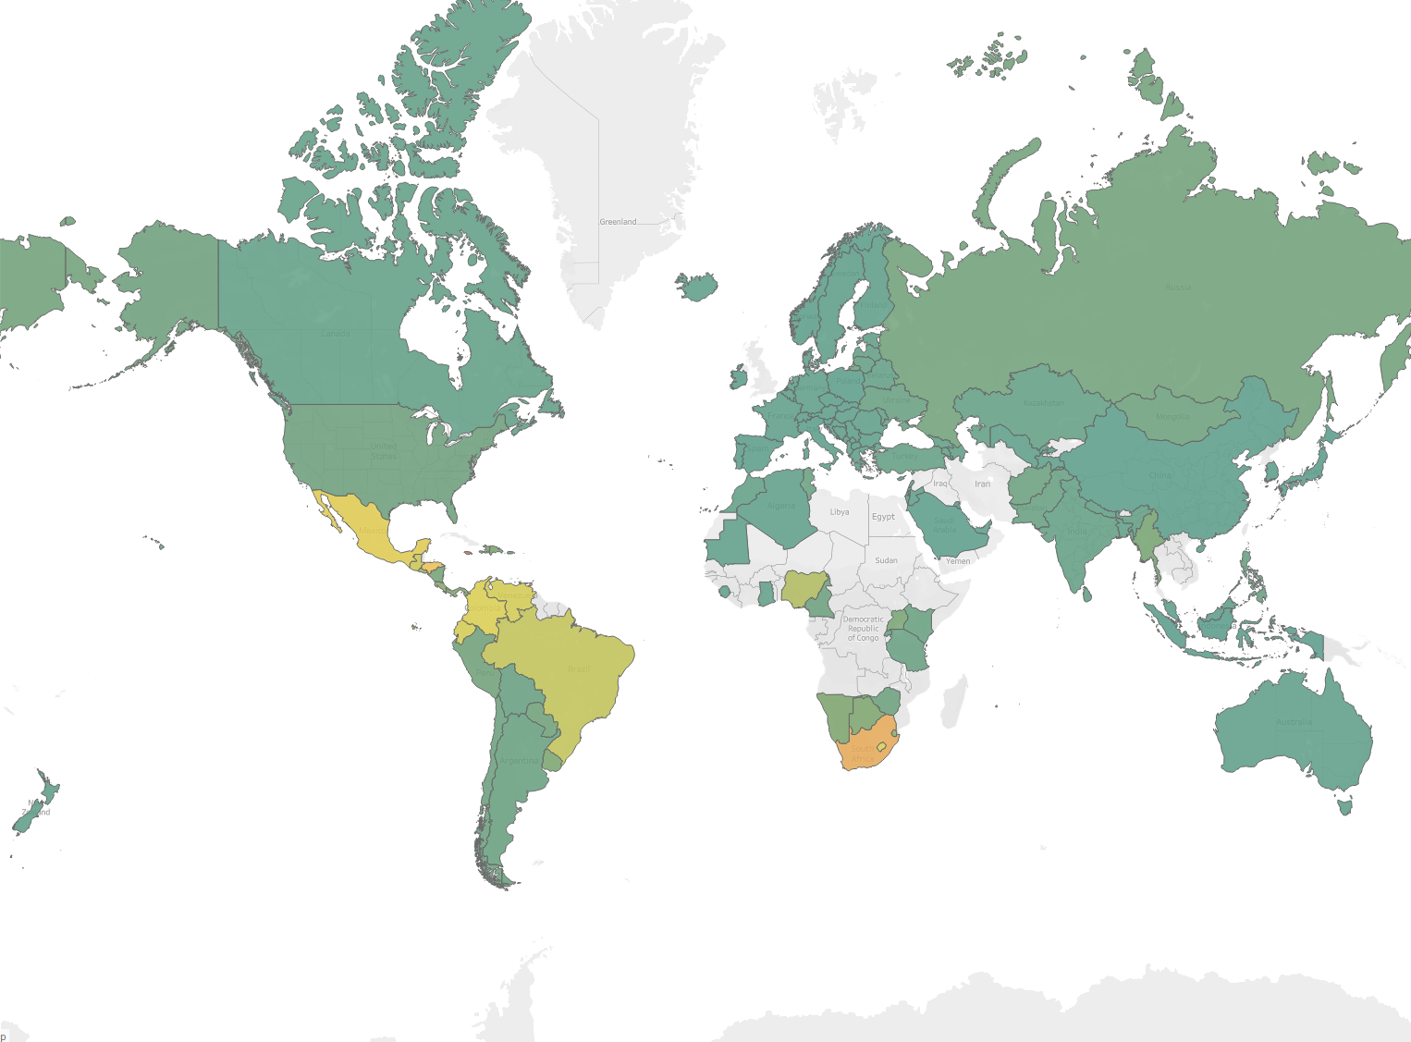
Figure 15: Homicide Rate Map (Green-Less, Orange-More)
Figure 15 supports the earlier statement about Latin American countries having higher serious crime rates.
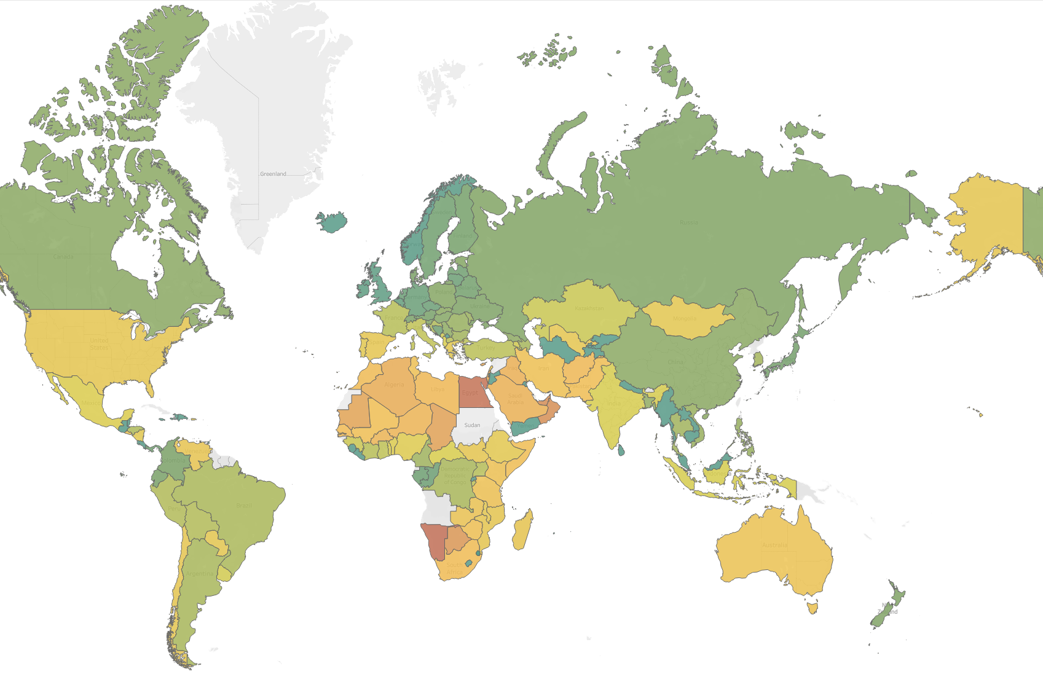
Figure 16:Sunshine Hours Map (Green-Less, Orange-More)

- Conclusion

  - Evaluation of artefact
The results indicate that the expanded feature set predicts country-level life evaluation more accurately than the baseline WHR feature set within the retained sample. The improvement is large enough to justify further investigation into the addition of new variables.
As the predictive power is not necessarily causal, this investigation should not be used to directly inform policy, but rather prompt investigation.
The findings are consistent with the relevant literature, although only at a broad level. For example, retirement age may reflect welfare institutions rather than leisure itself, and homicide rates may differ from perceived safety.
The clusters remain valuable even though they are not Random Forest predictors. They provide a way to compare country profiles across the base and expanded factors, and they can provide an effective way of viewing more homogenous groups within the dashboard. However, as the clusters are simulated, caution should be applied when making assertions about individual countries within a class.
The R script provides a repeatable workflow with fixed seeds and clearly writes results to png and table formats. Feature-importance plots show which variables the Random Forest relied upon most heavily. Scatter plots provide description of the relationship between each new variable and life evaluation. Cluster tables and plots show how country profiles differ across the original and added variables. The Tableau dataset allows these results to be explored geographically and by continent.
  - Limitations of approach
The study would benefit from a greater variety of indicators and duller data coverage. This would enable firmer conclusions to be drawn about the driver of happiness.
The fact that so large a proportion of data was removed means that results may not be representative of a balanced picture – countries without enough data to remain in the model may be ones with similar traits (eg. Low GDP).
Additional variables relating to each area would strengthen the view on the whole area. For example, homicide is well-defined, but it is not the same as perceived safety. It can also be under-recorded or concentrated in places that differ greatly from the country average, and it itself is an extreme crime. Bringing in other less serious crimes may produce a more balanced selection.
Cultural differences may result in participants of the poll used in the WHR to have different interpretations of what life satisfaction may mean. Emerson, S.D., Guhn, M. and Gadermann, A.M. (2017) reviewed measurement invariance of the Satisfaction with Life Scale and found that full comparability across cultures was rarely demonstrated. Uchida, Norasakkunkit and Kitayama (2004) contrasted the American achievement orientated perception of happiness with the more interpersonal relations focused interpretation of East Asian contexts.
External variables have uneven country and year coverage. The 50% threshold was a compromise and a greater number of new factors may result in more usable predictors. Some missing data may hurt the model’s accuracy, especially if the missing values tend to be in the lower happiness cluster.
Data represents country-level aggregates. Results cannot be applied directly to individuals within those countries.
Random Forest is a static model which does not do anything to represent changes over time or anomalous events (COVID-19)
As the clusters are not integrated into the model as with the reference paper, their relevance to the end result is limited. Further investigations may omit the creation of clusters. The project is unfocused in scope and could use honing further into a single question for deeper insight. Initially the plan was to more closely replicate Yang and Xie’s study where they integrated the clusters into their predictive model, however the importance of the clustering step was downgraded when it became clear their predictive power would be too strong.
6.3 Extent to Which the Aims Have Been Met and Next Steps
The main aim has been met. The project successfully created a merged country-level dataset, compared a baseline WHR Random Forest model with an expanded model, produced clustering outputs and created dashboard-ready data. The results show improved predictive performance. However, the scope to which they have been met is limited. Greater data coverage and a more granular approach would be beneficial.
A beneficial follow-up would be to remove one introduced variable, or perhaps group, at a time, and recalculate RMSE and R-squared. This would show whether the contribution of an individual factor is. Scatter plots are not sufficient evidence of predictive power. Additional data should be sourced to make up for what was dropped in this project, so that each area has multiple datasets associated. These should be as complete as possible to avoid dropping any more observations than necessary.
6.4 Extent to Which the Problem Has Been Solved
The problem cannot be considered completely solved as happiness is influenced by many variables. The incomplete dataset also means the model cannoc claim equal relevance for every country.
6.5 Record of meetings with Supervisor.
Meetings were held once every two weeks. Scheduling was handled with a recurring Microsoft Teams event.
Days of meetings were:
09/4
23/4
5/5
19/5
2/6
16/6
30/6
14/7
28/7
11/8

Initially this project was going to concern global ADHD rates and correlation with social media usage. Unfortunately, public data on healthcare is inconsistent in its availability especially on a worldwide scale, and so I needed to pivot my project to this instead. This happened during month 2 of the project.
- References
Alfaro-Beracoechea, L., Puente, A., da Costa, S., Ruvalcaba, N. and Páez, D. (2018) ‘Effects of fear of crime on subjective well-being: A meta-analytic review’, European Journal of Psychology Applied to Legal Context, 10(2), pp. 89–96. doi: 10.5093/ejpalc2018a9.
Buscha, F. (2016) ‘Does daily sunshine make you happy? Subjective measures of well-being and the weather’, The Manchester School, 84(5), pp. 642–663. doi: 10.1111/manc.12126.
Deaton, A. (2008) ‘Income, health, and well-being around the world: Evidence from the Gallup World Poll’, Journal of Economic Perspectives, 22(2), pp. 53–72. doi: 10.1257/jep.22.2.53.
Fischer, R. and Van de Vliert, E. (2011) ‘Does climate undermine subjective well-being? A 58-nation study’, Personality and Social Psychology Bulletin, 37(8), pp. 1031–1041. doi: 10.1177/0146167211407075.
Haar, J.M., Russo, M., Suñe, A. and Ollier-Malaterre, A. (2014) ‘Outcomes of work-life balance on job satisfaction, life satisfaction and mental health: A study across seven cultures’, Journal of Vocational Behavior, 85(3), pp. 361–373. doi: 10.1016/j.jvb.2014.08.010.
International Labour Organization (ILO) (2026) ILOSTAT: Average weekly hours actually worked per employed person [dataset]. Available from: https://ilostat.ilo.org/data/ [Accessed 03 September 2026].
Emerson, S.D., Guhn, M. and Gadermann, A.M. (2017) ‘Measurement invariance of the Satisfaction with Life Scale: Reviewing three decades of research’, Quality of Life Research, 26(9), pp. 2251–2264. doi: 10.1007/s11136-017-1552-2.
Kaggle (no date) Sunshine hours for cities around the world [dataset]. Available from: https://www.kaggle.com/datasets/bilalwaseer/sunshine-hours-for-cities-around-the-world [Accessed 02 September 2026].
Liu, S., Zhang, X. and Zhao, C. (2025) ‘Happiness in the sky: The effect of sunshine exposure on subjective well-being’, Biodemography and Social Biology, 70(2), pp. 67–81. doi: 10.1080/19485565.2025.2487977.
MacQueen, J. (1967) ‘Some methods for classification and analysis of multivariate observations’, in Le Cam, L.M. and Neyman, J. (eds.) Proceedings of the Fifth Berkeley Symposium on Mathematical Statistics and Probability. Berkeley: University of California Press, pp. 281–297.
Nilsson, A.H., Eichstaedt, J.C., Lomas, T., Schwartz, A. and Kjell, O. (2024) ‘The Cantril Ladder elicits thoughts about power and wealth’, Scientific Reports, 14(1), article 2642. doi: 10.1038/s41598-024-52939-y.
Noda, H. (2020) ‘Work-life balance and life satisfaction in OECD countries: A cross-sectional analysis’, Journal of Happiness Studies, 21(4), pp. 1325–1348. doi: 10.1007/s10902-019-00131-9.
OECD (2022) ‘Well-being, productivity and employment: Squaring the working time policy circle’, OECD Employment Outlook 2022 [online]. Paris: OECD Publishing. Available from: https://www.oecd.org/en/publications/oecd-employment-outlook-2022_1bb305a6-en/full-report/component-9.html [Accessed 02 September 2026].
OpenAI (2026) ChatGPT [generative AI tool]. Available from: https://chatgpt.com/ [Accessed 03 September 2026].
Ritchie, H., Rodés-Guirao, L., Arriagada, P. and Ortiz-Ospina, E. (2026) ‘Share of people who attend religious services frequently’, Religion [dataset]. Our World in Data. Available from: https://archive.ourworldindata.org/20260817-180151/grapher/share-attending-religious-services.html [Accessed 03 September 2026].
Rousseeuw, P.J. (1987) ‘Silhouettes: A graphical aid to the interpretation and validation of cluster analysis’, Journal of Computational and Applied Mathematics, 20, pp. 53–65. doi: 10.1016/0377-0427(87)90125-7.
Thorndike, R.L. (1953) ‘Who belongs in the family?’, Psychometrika, 18, pp. 267–276. doi: 10.1007/BF02289263.
Uchida, Y., Norasakkunkit, V. and Kitayama, S. (2004) ‘Cultural constructions of happiness: Theory and empirical evidence’, Journal of Happiness Studies, 5(3), pp. 223–239. doi: 10.1007/s10902-004-8785-9.
United Nations Office on Drugs and Crime (no date) Intentional homicide victims [dataset]. Available from: https://data.unodc.org/datareport/hom-victim [Accessed 02 September 2026].
United Nations Office on Drugs and Crime (UNODC) (no date) Sustainable Development Goal indicator 16.1.4: Proportion of population that feel safe walking alone around the area they live after dark [dataset]. Available from: https://data.unodc.org/datareport/sdg-16-1-4 [Accessed 03 September 2026].
World Happiness Report (2025) World Happiness Report 2025 [online]. Oxford: Wellbeing Research Centre, University of Oxford. Available from: https://worldhappiness.report/ [Accessed 02 September 2026].
World Population Review (2026) Average vacation days by country [online]. Available from: https://worldpopulationreview.com/country-rankings/average-vacation-days-by-country [Accessed 03 September 2026].
World Population Review (2026) Retirement age by country [online]. Available from: https://worldpopulationreview.com/country-rankings/retirement-age-by-country [Accessed 03 September 2026].
Yang, B. and Xie, X. (2025) ‘Analyzing and predicting global happiness index via integrated multilayer clustering and machine learning models’, PLOS ONE, 20(4), e0322287. doi: 10.1371/journal.pone.0322287.
